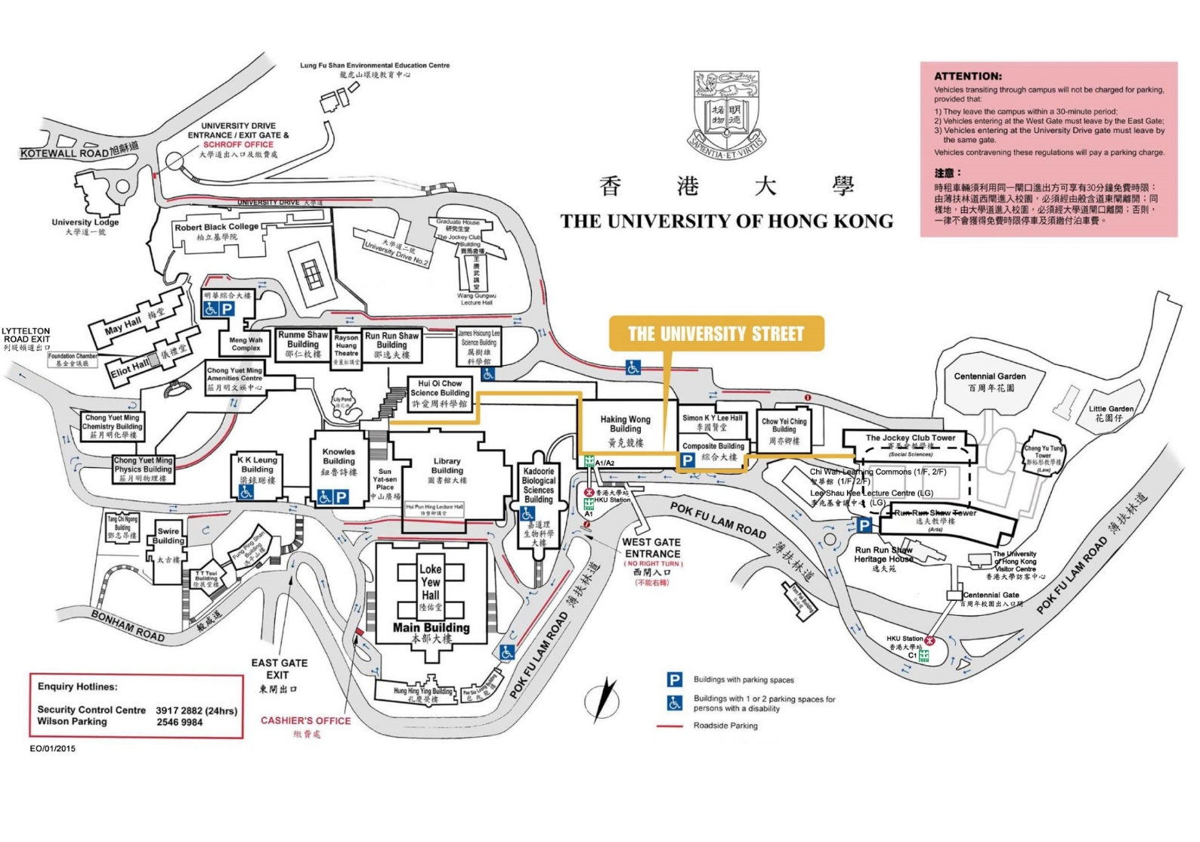

Room CBC, LG1/F,   
Chow Yei Ching Building  
香港大學周亦卿樓LG1/F - CBC