About Parenting for a Peaceful World

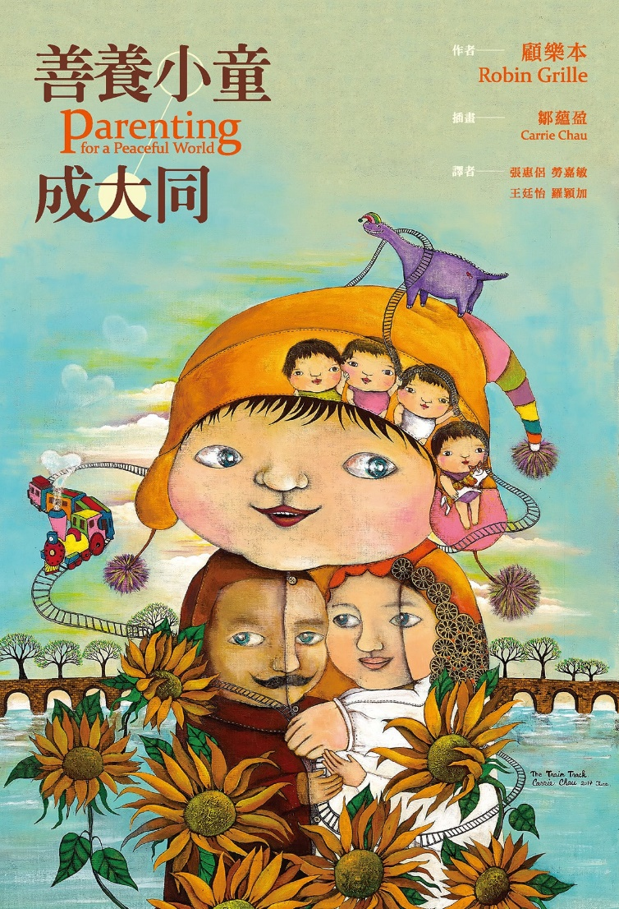
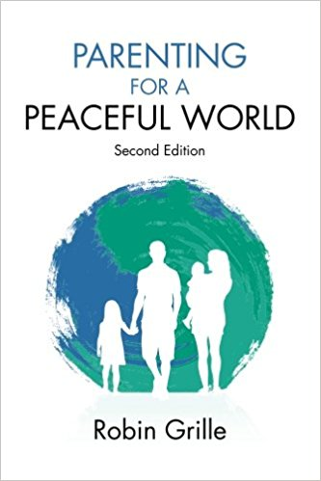
Has it come across to you that how we raise a child can affect our society and even our world? Have you ever imagined that social ills like war, pollution, drug abuse, violence, workaholism, human trafficking, and child abuse… are related to our collective parenting style?

Robin Grille, the author of Parenting for a Peaceful World researched for 10 years and wrote in 5 years this book that combines a multitude of research including psychohistory, neurobiology, anthropology, sociology, alternative education and psychotherapy. He started by outlining six modes of parenting styles that prevail in different time of history: “infanticidal mode” > “abandoning mode” > “ambivalent mode” > “intrusive mode” > “socialising mode” > the most modern and progressive, “helping mode”. Grille illustrates how these modes relate to major historical events; uses neuroscience to explain the effect of parenting on the growing brain, and makes suggestions for self-reflection so we can be aware of the possible reasons behind and origin of our own parenting style.

Grille points out that irrespective of society and race, all violence originates from an authoritarian parenting style. Throughout the years, the overall parenting style has largely evolved to building more loving relationships. As the foundation for emotional quotient starts from childhood, the more empathy children experience, the fairer and more democratic a society can become.

It takes a village to raise a child: the book states that children used to be seen as properties of their parents and hence they were not mentioned in human rights manifestos by US, UK and France in the 18th century. In 200 years, free education and children protection policies such as maternity and paternity leaves, maternity clinics, and anti-corporal punishment laws have been introduced. Whether parents can give their children their best depends if the government and business sector can also give them proper support so they have enough time, energy and emotional resources to be with their children.

These are 5 messages that the author would like the readers to take home:

- Our children’s emotional needs is just as important as their material and bodily needs;
- Modern brain science and child-development science has given the world an unprecedented level of knowledge about how to best help our children to thrive.
- Parenting behavior is learned, and it keeps evolving through history;
- Parents cannot parent alone, and we require the support of a ‘village’.
- As cultures move – with increasing speed! – away from authoritarian styles of parenting and education, we are creating a more peaceful, democratic and harmonious world.

EDiversity is a parent-initiated charity founded in Hong Kong in 2014. It crowdfunded and spent two years translating this book and published it in Chinese in December 2017, hoping to benefit more people in the Chinese speaking world. The book has been turned into a three-year parenting programme thanks to the generosity of D.H.Chen Foundation, the charity’s core partner & funder for the programme.

